

**KingAbdulazizUniversity**

**Faculty of Computing & Information Technology**

**Computer Science Department**

**CPCS-351 Software Engineering I**

**Fall -2019-2020**

**Final Project Report**



**[Telemedicine Application]**

|  |  |
| --- | --- |
| **Student Name** | **Student Number** |
| **Abdulrahman Mohammed Alharthi** | **1741096** |
| **Abdulrahman Khalid Alwagdani** | **1740216** |
| **Omar Abdulaziz Alqurashi** | **1742589** |
| **Hussam Adnan Shawly** | **1742403** |
| **Mohammed ALzahrani** | **1740166** |
| **Ammar Talat Joharji (Leader)** | **1742559** |

# CONTENTS

**1. PHASE 1 4**

**1.1 Introduction 4**

**1.2** **Project Goals And objectives 5**

**1.3 Project team ……………………………………………………………………………………………………………………. 6**

**1.4 Project Scope …………………………………………………………………………………………………………………… 7**

**1.4.1 Included …….…………………………………………………..…………………….…………………………………...………….. 7**

**1.4.2 Excluded ….…….…………………………………………………………….…….……………………………………….…..….... 7**

**1.5 Domain analysis …………..……………………………………….……………………….……………………………………..…… 8**

**1.6 Requirements & its types ….…….………..……………….…………………….………………….…………………………… 9**

**1.6.1 Techniques for gathering data …….…………….………………….…………………………………….….…….….. 10**

**1.7 Use Cases …………………………..………………………….………….............................................................. 11**

**1.7.1 Use case diagram for given problem …….…………………..………………………..………………….……….. 31**

**2. PHASE 2 33**

**2.1 Converting use cases to class diagram 33**

**2.2** **UML class diagram 33**

**2.2.1 Association 34**

**2.2.1.1 Composition 34**

**2.2.1.1 Aggregation 34**

**2.2.2 Multiplicity 35**

**2.2.3 Generalization 36**

**3. PHASE 3 37**

**3.1 Sequence Diagram for 37**

**3.1.1 Search for Topic 37**

**3.1.2 Start Live Chat 38**

**3.2 State Diagram for 39**

**3.2.1 Delete Topic 39**

**3.2.2 Start Live Chat 40**

**3.3** **Activity Diagram for 41**

**3.3.1 Client and doctor to start Live Chat 41**

**3.3.2 Doctor to be verified 42**

**3.3.3 Client requests to get paternalized from a doctor 43**

**3.4** **Architecture Diagram 44**

**4. PHASE 4 45**

**4.1** **Test design scenarios 45**

**4.1.1 Create Topic Test 45**

**4.1.2 Live chat Test 45**

**4. BIBLOGRAPH 46**

**5. APPENDIX-A: Update and meeting table 47**

**6. APPENDIX-B: Interview Questions 48**

**ILLUSTRATION**

**Figure1: Use case Diagram for all users 31**

**Figure2: Use case Diagram for each user 32**

**Figure3: UML Diagram 33**

**Figure4: Sequence diagram for Search for a topic 37**

**Figure5: Sequence diagram for Start Live Chat 38**

**Figure6: State diagram Delete Topic 39**

**Figure7: State diagram for Start Live Chat 40**

**Figure8: Activity Diagram for client and doctor to start Live Chat 41**

**Figure9: Activity Diagram for a doctor to be verified 42**

**Figure10: Activity Diagram for a client requests to get paternalized from a doctor 43**

**Figure11: Architecture Diagram 44**

**PHASE 1 :-**

1. **Introduction:**

A study by PWC Consulting found that 54% of healthcare customers (patients) prefer to use digital healthcare applications to receive health care for himself or herself or a family member. It is a set of applications for smart devices, which enable the patient to access his medical data and communicate with Health care provider. (Reference number “6” in BIBLOGRAPHY).

**In this project, our main concern is**Telemedicine, which is a form of medical practice that relies on the use of advanced communication technologies to share health information and provide health care, regardless of time, geographic, or even cultural and social barriers.

**Telemedicine has several benefits, the most important of which are:**

1. Reducing patient transportation expenses.
2. Communication between the patient and the doctor with the comfort of the patient.
3. Multimedia may further improve health care process.

**Telemedicine Application is** an application that provides communication among the community such that a patient can communicate directly with a doctor in a private room, however, it also provides a huge forum community that enables the clients to further get benefits and explore medical related topics.

Doctors who are online can be chosen by a client and then clients can start a private room if the doctor accepts it.

In private room, patient can ask the doctor about his/her diseases and get the answer from the doctor. Moreover, it supports many media to let the patient explain his disease in much more efficient manner, these medias can be text, audio or even more a live video streaming.

**1.2 Project objectives & Goals**

The general goals for the project are:

* Ability to improve more humans' health globally.
* Facilitate the patient’s lives (no need to go to a desirable doctor who is too far away from the patient's residence)
* Providing social and psychological support to patients and their families and solving their problems
* Facilities the communication between doctor and patient
* Reduce congestion in health centers and provide telemedicine services

The objectives and goals for each stakeholder are shown in the following table:

|  |  |  |
| --- | --- | --- |
| Table1: Stakeholders Objectives and Goals | | |
| Stakeholder | Objective(s) | Goal(s) |
| Visitor | 1. The user can browse any topic related to the medicine. 2. The user can register. | Increase client and user:  Satisfaction.  Convenience. |
| Client | 1. Allow the client to login. 2. Enabling the client to ask a question about his disease in:    1. Public so doctors that are specialist in the field of this question can answer.    2. Private in which a doctor who has an agreement with a patient can privately answer the question. 3. Enabling the client to search for registered doctors and their information. 4. Enabling the client to look for public patients' questions that are related to his disease and seeing doctors' answers. |
| Doctor | 1. Allow them to login 2. Enabling the registered doctor to answer question/s in public or private 3. Enabling the registered doctor to continue tracking his patient's health state 4. Enabling the registered doctor to communicate with a patient who has an agreement with him. 5. Enabling the registered doctor to create a useful topic related to the medicine 6. Give codes to patients for later. | Increase the community awareness on various health issues.  Provide easy diagnoses for lower class patients. |
| Administrator | 1. Manage topics 2. Manage accounts 3. Retrieve feedback about users' experience | Organize the community, so that it can be readable.  Enforce the rules of the application. |

**1.3 Project team**

**(Group leader)**

**Name:** Ammar Talat Joharji

**ID:** 1742559

**E-mail:** ajawharji@stu.kau.edu.sa

**Phone number:** 0559644775

**Name:** Mohammed Atiah Alzahrani

**ID:** 1740166

**E-mail:** Mezn30000@gmail.com

**Phone number:** 0506692884

**Name:** Omar Abdulaziz Alqurashi

**ID:** 1742589

**E-mail:** oalqurashi0018@stu.kau.edu.sa

**Phone number:** 0549281172

**Name:** Abdulrahman Mohammed Alharthi

**ID:** 1741096

**E-mail:** aalharthy0177@stu.kau.edu.sa

**Phone number:** 0565994326

**Name:** Hussam Adnan Shawly

**ID:** 1742403

**E-mail:** hshawly@stu.kau.edu.sa

**Phone number:** 0598448617

**Name:** Abdulrahman Khalid Alwagdani

**ID:** 1740216

**E-mail:** aalwagdani0012@stu.kau.edu.sa

**Phone number:** 0582877738

**1.4 Project Scope**

We must clarify the boundaries of this work, what is involved and what is not involved. Here is a list that shows which activities are included and which are not:

Include:

* List active topics.
* Interactive chat between doctor and client.
* Software portability.
* Community platform where clients and doctors can create topics and post replies.
* Multimedia support (Pictures , voice chat , videos or text).
* Good security measurements.
* Friendly user interface.
* Provide a technical support team.

Exclude:

* Appointment system.
* Medicine alarm system
* Client medical information is not provided.
* Blood bank system.
* Association with any hospital (Doctors may register from different hospitals).

**1.5 Domain analysis**

We have analyzed an existing application that perform similar activities, it’s called “Sehha”. It enables the users to send a picture, text, voice and audio chat with doctors to discuss about their disease and problems. We have observed the following:

|  |  |
| --- | --- |
| Table2: Facts explanation | |
| Facet | Details |
| Type of Business | Medical Community. |
| Parts of the business | * Community Management. * Consultation service. * Communication service. |
| How does it operate | 1. Sign in as doctor or user or enter the system as visitor 2. The visitor can explore the most commonly asked question and their arguments 3. The user can ask question and join private conversation with his doctor 4. The doctor can reply to question that is related to his filed, and can also join private conversation with his patient |
| Business’s System  environment/context | * iOS * Android |
| Problems with the current system | * The current system doesn’t provide community forum. |

**1.6 Requirements & its types**

The requirements are categorized as following :

Functional Requirements:

1. General Functional Requirements:

**All users shall:**

* GR.1: View Topic.
* GR.2: Search for Topic

**All registered users shall:**

* GR.3: Login into the system.
* GR.4: Rate the app.
* GR.5: View archived topics.
* GR.6: Create topic.
* GR.7: Delete topic.
* GR.8: Track topic.
* GR.9: Reply to topic.
* GR.10: Logout of the system.

1. **Specific Functional Requirements:**

* A. Visitor: **The app shall allow the Visitor to:**
  + RG.1: Register.
* B. Client: **The app shall allow the client to:**
  + RC.1: Request to be paternalized from doctor via e-mail and private live chat acceptance.
  + RC.2: Exchange emails with a doctor.
  + RC.3: List online doctors.
  + RC.4: Start private live chat with doctor.
  + RC.5: View private text live chat history.
* C. Doctor: **The app shall allow the doctor to:**
  + RD.1: Accept or reject client’s request to paternalize him/her via e-mail and private chat.
  + RD.2: Request for verification from administrator.
  + RD.3: Exchange emails with client.
  + RD.4: List client’s queue for private live chat.
  + RD.5: Answer or decline client’s private live chat.
  + RD.6: View private text live chat history.
* D. Administrator: **The app shall allow the administrator to:**
  + RA.1: Verify Doctors.
  + RA.2: Pin topics.
  + RA.3: Close topics.
  + RA.4: Move topics.
  + RA.5: Delete account.
  + RA.6: Ban account.
  + RA.7: Reply to feedback.
  + RA.8: Change Forum’s Name.
  + RA.9: Change Section Name.
  + Update System Information.

**Non-Functional Requirements:**

* Efficient communication between doctors and clients.
* Audio and video streaming should be fast without delays and lags.
* The interface of icons and options preferred to be organized.
* The system shall encrypt connection with clients and doctors.

**1.6.1 Techniques for gathering data**

We have used several methods or techniques for gathering the data and requirements, which includes:

* **Brainstorming** with team members.
* **Observation** from similar system, as well as, we analyzed some real existing systems and its reviews from users. We tried to maximize the benefits. Some problems or were :
  + - * Problems with registration: Verification code is not sent after registration.
      * It doesn’t have community forum.
* **Patients interviewing.**
* **Internet** (See BIBLIOGRAPHY)

**1.7 Use Cases**

|  |  |
| --- | --- |
| Table3:Use Case Documentation Template | |
| Use Case ID: | G1 |
| Use Case Name: | View Topic |
| Actors: | |
| All users | |
| Flow of Events of the Primary Scenario: | |
| 1. Select "Topics" from the menu. 2. Topics will be displayed. 3. Select the desired Topic. | |
| Flow of Events of the Alternative Scenarios: | |
| 1. Login into the system. 2. Select “Topics” from the menu. 3. Topics will be displayed. 4. Select the desired Topic. | |
| Extension Points: | |
| 3a. You can choose to filter the topics.  ---3a1. Topics will be displayed according to specified filter.  ---3a2. Select desired topic.  3b. you can choose a section to browse the topics from.  ---3b1.Topics from a specific section will be displayed only.  ---3a2. Select desired topic. | |
| Postconditions: | |
| Show the content of chosen topic. | |

|  |  |
| --- | --- |
| Table4:Use Case Documentation Template | |
| Use Case ID: | G2 |
| Use Case Name: | Search for Topic |
| Actors: | |
| All users | |
| Flow of Events of the Primary Scenario: | |
| 1. Select “Topics” from the menu. 2. Go to the search bar. 3. Select search type i.e. author name, topic name. 4. Click on the “Search” button. 5. Type topic name to be searched 6. Show the topic. | |
| Flow of Events of the Alternative Scenarios: | |
| 1. Select “Topics” from the menu. 2. Go to the search bar. 3. Select search type i.e. author name, topic name. 4. Click on the “Search” button. 5. Type topic name to be searched 6. No topic is matched, show appropriate message | |
| Extension Points: | |
| 4a. You can choose to filter the topics. | |
| Postconditions: | |
| Show the topics that match the search. | |

|  |  |
| --- | --- |
| Table5:Use Case Documentation Template | |
| Use Case ID: | G3 |
| Use Case Name: | Login |
| Actors: | |
| All registered users | |
| Flow of Events of the Primary Scenario: | |
| 1. Start the system. 2. Select “Login” from the main menu. 3. type the user name and password. 4. Click on “Login”. 5. Wait for verification. | |
| Flow of Events of the Exception Scenarios: | |
| 1. The entered user name or password is incorrect.    1. A message will be displayed “Incorrect user name or password”.    2. Type the user name or password again. 2. The user doesn’t exist in the system.    1. Register into the system. | |
| Postconditions: | |
| The registered user gains access to his account. | |

|  |  |
| --- | --- |
| Table6:Use Case Documentation Template | |
| Use Case ID: | G4 |
| Use Case Name: | Rate the App |
| Actors: | |
| All registered users | |
| Preconditions: | |
| The user must be logged into the system. | |
| Flow of Events of the Primary Scenario: | |
| 1. Select “Rate us” from the main menu. 2. choose a rating from 0 to 5 stars. 3. “Write a comment” will be displayed. 4. Type a review. 5. Click on “Post”. | |
| Extension Points: | |
| 3a. The user can click on the “X” to not leave a message. | |
| Postconditions: | |
| The registered user review and rating will be available on the application. | |

|  |  |
| --- | --- |
| Table7:Use Case Documentation Template | |
| Use Case ID: | G5 |
| Use Case Name: | Create Topic |
| Actors: | |
| All registered users | |
| Preconditions: | |
| The user must be logged into the system. | |
| Flow of Events of the Primary Scenario: | |
| 1. The doctor selects “Topics” from the menu. 2. Clicks on ‘Create topic’. 3. Select the topic type i.e. “Informative”, “Question” . 4. Selects the topic section. 5. Writes the title and the body of the topic. 6. Click on ‘Post’**.** | |
| Postconditions: | |
| The system publishes the created topic in the public community. | |

|  |  |
| --- | --- |
| Table8:Use Case Documentation Template | |
| Use Case ID: | G6 |
| Use Case Name: | Check Topic's New Replies |
| Actors: | |
| All registered users | |
| Preconditions: | |
| 1. The user must log into the system 2. The user must have created at least one topic | |
| Flow of Events of the Primary Scenario: | |
| 1. Select "My topics" on the main screen. 2. Select a topic that has a notification sign on it. | |
| Postconditions: | |
| The registered user sees the new replies on the selected topic | |

|  |  |
| --- | --- |
| Table9:Use Case Documentation Template | |
| Use Case ID: | G7 |
| Use Case Name: | Reply to Topic |
| Actors: | |
| All registered users | |
| Preconditions: | |
| The user must be logged into the system.  The topic must be existed. | |
| Flow of Events of the Primary Scenario: | |
| 1. Select "Topics" from the menu. 2. Choose any topic from a list of topics. 3. Send a reply to the chosen topic. | |
| Extension Points: | |
| 2a. You can choose to filter the topics. | |
| Postconditions: | |
| The system shows the topic with registered user reply. | |

|  |  |
| --- | --- |
| **Table10:Use Case Documentation Template** | |
| Use Case ID: | G8 |
| Use Case Name: | View Archived Topic |
| Actors: | |
| All registered users | |
| Preconditions: | |
| 1. The user must log into the system. 2. The user must have created at least one archived topic. | |
| Flow of Events of the Primary Scenario: | |
| 1. Select "Topics" on the main screen. 2. Select “Archived Topics” from the topic menu. 3. Choose a topic. | |
| Extension Points: | |
| 2a. You can choose to filter the topics. | |
| Postconditions: | |
| The registered user views his/her archived topic. | |

|  |  |
| --- | --- |
| Table11:Use Case Documentation Template | |
| Use Case ID: | G9 |
| Use Case Name: | Delete topic |
| Actors: | |
| All registered users | |
| Preconditions: | |
| The user must be logged into the system. | |
| Flow of Events of the Primary Scenario: | |
| 1. Select "Topics" from the menu. 2. Tick specified topic. 3. Click on “Delete”. | |
|  | |
| Extension Points: | |
| 2a. You can choose to filter the topics. | |
| Postconditions: | |
| The system deletes the specified topic from the public community. | |

|  |  |
| --- | --- |
| Table12:Use Case Documentation Template | |
| Use Case ID: | G10 |
| Use Case Name: | Logout |
| Actors: | |
| Client, Doctor, Admin. | |
| Preconditions: | |
| The user must be logged into the system. | |
| Flow of Events of the Primary Scenario: | |
| 1. Select "Logout" from the menu. 2. A confirmation message will appear. 3. Click on “Yes”. | |
|  | |
| Postconditions: | |
| The user logs out of the application. | |

|  |  |
| --- | --- |
| Table13:Use Case Documentation Template | |
| Use Case ID: | GU1 |
| Use Case Name: | Register |
| Actors: | |
| Visitor. | |
| Flow of Events of the Primary Scenario: | |
| 1. Select " Registration" from the menu. 2. Fill the Registration from. 3. The system sends a verification mail. 4. The user verifies the account. | |
| Postconditions: | |
| The user has an account in the system. | |

|  |  |
| --- | --- |
| **Table14: Use Case Documentation Template** | |
| Use Case ID: | C2 |
| Use Case Name: | List Online Doctors |
| Actors: | |
| Client. | |
| Preconditions: | |
| The client must be logged into the system. | |
| Flow of Events of the Primary Scenario: | |
| 1. Select "Doctors" from the menu. 2. Online doctors will be listed. | |
| Flow of Events of the Alternative Scenarios: | |
| 1. search for the doctor by name. | |
| Postconditions: | |
| List all online doctors. | |

|  |  |
| --- | --- |
| **Table15:Use Case Documentation Template** | |
| Use Case ID: | C1 |
| Use Case Name: | Request to be paternalized |
| Actors: | |
| Client, doctor | |
| Preconditions: | |
| The client must be logged into the system. | |
| Flow of Events of the Primary Scenario: | |
| 1. Select "Doctors" from the menu. 2. List all available doctors. 3. Chose a doctor 4. Click on “Request to be paternalized” 5. Doctor accepts the request. | |
| Flow of Events of the Alternative Scenarios: | |
| 1. Select "Doctors" from the menu. 2. List all available doctors. 3. Chose a doctor 4. Click on “Request to be paternalized” 5. Doctor rejects the request. | |
| Flow of Events of the Exception Scenarios: | |
| * This client is already paternalized with chosen doctor | |
| Postconditions: | |
| Client get paternalized or not paternalized by chosen doctor. | |

|  |  |
| --- | --- |
| Table16:Use Case Documentation Template | |
| Use Case ID: | C3 |
| Use Case Name: | Start Live Chat with doctor |
| Actors: | |
| Client, doctor | |
| Preconditions: | |
| The client must be logged into the system.  The doctor must exist in the system.  The doctor accepted to paternalize this client | |
| Flow of Events of the Primary Scenario: | |
| 1. Select “Private Communication” from main menu. 2. Select the specified Doctor. 3. Click on Start Live Chat. 4. Doctor accepts the private chat. | |
| Flow of Events of the Alternative Scenarios: | |
| 1. The doctor declines the chat request.   A message is sent to the client “The request has been declined”. | |
| Postconditions: | |
| Start the Live chat between client and doctor | |

|  |  |
| --- | --- |
| Table17:Use Case Documentation Template | |
| Use Case ID: | C4 |
| Use Case Name: | Exchange emails with doctor |
| Actors: | |
| Client | |
| Preconditions: | |
| The client must be logged into the system.  The doctor must exist in the system.  The doctor accepted to paternalize this client | |
| Flow of Events of the Primary Scenario: | |
| 1. Select “Private Communication” from main menu. 2. Select the specified Doctor. 3. Click on “Open mailbox”. | |
| Postconditions: | |
| The client accesses his mailbox with the chosen doctor. | |

|  |  |
| --- | --- |
| Table18:Use Case Documentation Template | |
| Use Case ID: | C5 |
| Use Case Name: | View Private Text Live Chat History |
| Actors: | |
| Client. | |
| **Description**: | |
| The client is able to view his/her Private chat with type “Text” only. Audio and Video are not concerned. | |
| Preconditions: | |
| The client must be logged into the system. | |
| Flow of Events of the Primary Scenario: | |
| 1. Select “Private Communication” from the main menu. 2. Select “Live Chat” 3. Select the desired question from the menu. | |
| Flow of Events of the Alternative Scenarios: | |
| 1. Select “Private Communication” from the main menu. 2. Select “Live Chat” 3. Select list option (Order by time or doctor). 4. Select the desired question from the menu. | |
| Flow of Events of the Alternative Scenarios: | |
| 1. Select “Private Communication” from the main menu. 2. Select “Live Chat” 3. No question has been asked yet. Print appropriate message | |
| Postconditions: | |
| Retrieve all online text question details with corresponding time and doctor reply. | |

|  |  |
| --- | --- |
| Table19:Use Case Documentation Template | |
| Use Case ID: | D1 |
| Use Case Name: | Request for verification from Administrator |
| Actors: | |
| Doctor. | |
| Preconditions: | |
| Doctor must be logged in.  Doctor must have a verification Method i.e. CV, LinkedIn. | |
| Flow of Events of the Primary Scenario: | |
| 1. The doctor selects “profile” from the menu. 2. Choose provide verification. 3. Doctor sends verification material. 4. “Verification pending” appears on his profile. | |
| Flow of Events of the Alternative Scenarios: | |
| 4a.The doctor cancels his verification process.  ---4a1. The doctor receives a message  4b.The doctor doesn’t get verified.  ---4b1. The doctor receives a message. | |
| Postconditions: | |
| The doctor gets verified from the administrator. | |

|  |  |
| --- | --- |
| Table20:Use Case Documentation Template | |
| Use Case ID: | D3 |
| Use Case Name: | View Private Text Live Chat History |
| Actors: | |
| Doctor | |
| Preconditions: | |
| The Doctor must be logged into the system. | |
| Flow of Events of the Primary Scenario: | |
| 1. Select “Private Communication” from the main menu. 2. Select “Live Chat” 3. Choose Text Live Chat History. 4. Select the name of the client. 5. Select specified answer. | |
| Postconditions: | |
| Retrieve all details of the conversation with corresponding time and client name. | |

|  |  |
| --- | --- |
| Table21:Use Case Documentation Template | |
| Use Case ID: | D4 |
| Use Case Name: | List Client’s Queue for Private Live Chat |
| Actors: | |
| Doctor | |
| **Description**: | |
| The doctor will have many paternalized clients that wish to start for private live chat with him/her. So, in order to apply this, we will put clients in a queue for justice. | |
| Preconditions: | |
| The doctor must be logged into the system. | |
| Flow of Events of the Primary Scenario: | |
| 1. Select “Private Communication” from the main menu. 2. Select “Live Chat” 3. Select “Show clients queue” | |
| Postconditions: | |
| Retrieve the details about queued clients. | |
| Table22:Use Case Documentation Template | |
| Use Case ID: | D2 |
| Use Case Name: | Exchange emails with client. |
| Actors: | |
| Doctor | |
| Preconditions: | |
| The doctor is logged into the system.  The doctor accepted to paternalize the client. | |
| Flow of Events of the Primary Scenario: | |
| 1. Select “Private Communication”. 2. Select “List Paternalized clients” 3. Select “Mailbox” 4. Write the message. 5. Select “Send”. | |
| Postconditions: | |
| The message is received by the client. | |

|  |  |
| --- | --- |
| Table23:Use Case Documentation Template | |
| Use Case ID: | A1 |
| Use Case Name: | Verify Doctor |
| Actors: | |
| Admin. | |
| Preconditions: | |
| The Admin must be logged into the system.  At least one doctor has sent verification. | |
| Flow of Events of the Primary Scenario: | |
| 1. Select "Doctor" from the menu. 2. Select "Unverified Doctors". 3. The system view list of Unverified Doctors. 4. The admin chose a doctor. 5. The admin verifies the doctor. | |
| Postconditions: | |
| The doctor account verified | |
| Table24:Use Case Documentation Template | |
| Use Case ID: | A2 |
| Use Case Name: | Pin/Unpin topic |
| Actors: | |
| Admin. | |
| Preconditions: | |
| The Admin must be logged into the system. | |
| Flow of Events of the Primary Scenario: | |
| 1. Select "Topics" from the menu. 2. Tick specified topic. 3. Click on “Pin”. | |
|  | |
| Flow of Events of the Alternative Scenarios: | |
| To Unpin specified topic:   1. Select "Topics" from the menu. 2. Tick specified topic. 3. Click on “Unpin”. | |
| Postconditions: | |
| The system either pins or unpins the specified topic in the public community in the pinned topics area. | |

|  |  |
| --- | --- |
| Table25:Use Case Documentation Template | |
| Use Case ID: | A3 |
| Use Case Name: | Close Topic |
| Actors: | |
| Admin. | |
| Preconditions: | |
| The Admin must be logged into the system.  The topic is existing. | |
| Flow of Events of the Primary Scenario: | |
| 1. Select "Topic" from the menu. 2. Chose a topic. 3. Select "Close Topic". | |
| Postconditions: | |
| The chosen topic closed. | |

|  |  |
| --- | --- |
| Table26:Use Case Documentation Template | |
| Use Case ID: | A4 |
| Use Case Name: | Move Topic |
| Actors: | |
| Admin. | |
| Preconditions: | |
| The Admin must be logged into the system.  The topic is existing. | |
| Flow of Events of the Primary Scenario: | |
| 1. Select "Topic" from the menu. 2. Chose a topic. 3. Select "Move Topic". 4. Select destination path. 5. Press Ok. | |
| Postconditions: | |
| The chosen topic moved to specified location. | |

|  |  |
| --- | --- |
| Table27:Use Case Documentation Template | |
| Use Case ID: | A5 |
| Use Case Name: | Delete account |
| Actors: | |
| Admin. | |
| Preconditions: | |
| Client already exists in the system. | |
| Flow of Events of the Primary Scenario: | |
| 1. Select a client. 2. Click on “Profile”. 3. Select “delete”. 4. Confirm delete. | |
| Postconditions: | |
| The client is either banned or his account is deleted. | |
| Table28:Use Case Documentation Template | |
| Use Case ID: | A6 |
| Use Case Name: | Ban Account |
| Actors: | |
| Admin. | |
| Preconditions: | |
| Client already exists in the system. | |
| Flow of Events of the Primary Scenario: | |
| 1. Select a client. 2. Click on “Profile”. 3. Select “ban”. | |
| “Used” Use Cases: | |
| 3a. The admin must specify the type of the ban.  3b. The admin must process ban request. | |
| Postconditions: | |
| The client is either banned or his account is deleted. | |

|  |  |
| --- | --- |
| Table29:Use Case Documentation Template | |
| Use Case ID: | A7 |
| Use Case Name: | Reply to feedback |
| Actors: | |
| Admin. | |
| Preconditions: | |
| The admin must be logged in. | |
|  | |
| Flow of Events of the Primary Scenario: | |
| 1. Select ‘Feedback and ratings’ from the app menu. 2. View all the reviews on the app. 3. Select ‘reply’ on specific review. 4. Type a message. 5. Click ‘send’. | |
| Postconditions: | |
| A reply will be posted on a specific review. | |
| Table30:Use Case Documentation Template | |
| Use Case ID: | A8 |
| Use Case Name: | Change Forum's Name |
| Actors: | |
| Admin. | |
| Preconditions: | |
| The Admin must be logged into the system. | |
| Flow of Events of the Primary Scenario: | |
| 1. Select "Change Forum's Name" from the menu. 2. Modify forum's name | |
|  | |
| Postconditions: | |
| The forum's name has been updated. | |

|  |  |
| --- | --- |
| Table31:Use Case Documentation Template | |
| Use Case ID: | A9 |
| Use Case Name: | Change Section's Name |
| Actors: | |
| Admin. | |
| Preconditions: | |
| The Admin must be logged into the system. | |
| Flow of Events of the Primary Scenario: | |
| 1. Select "Change Section's Name" from the menu. 2. Select the intended section. 3. Modify section's name. | |
|  | |
| Extension Points: | |
| 2a. You can choose to filter the sections. | |
| Postconditions: | |
| The section's name has been updated. | |

|  |  |
| --- | --- |
| Table32:Use Case Documentation Template | |
| Use Case ID: | A10 |
| Use Case Name: | Update System Info |
| Actors: | |
| Admin. | |
| Preconditions: | |
| The Admin must be logged into the system. | |
| Flow of Events of the Primary Scenario: | |
| 1. Select "About" from the menu. 2. Select "modify system info". 3. Modify one or more text fields. | |
|  | |
| Postconditions: | |
| The system info has been updated. | |

* + 1. **Use case diagram**

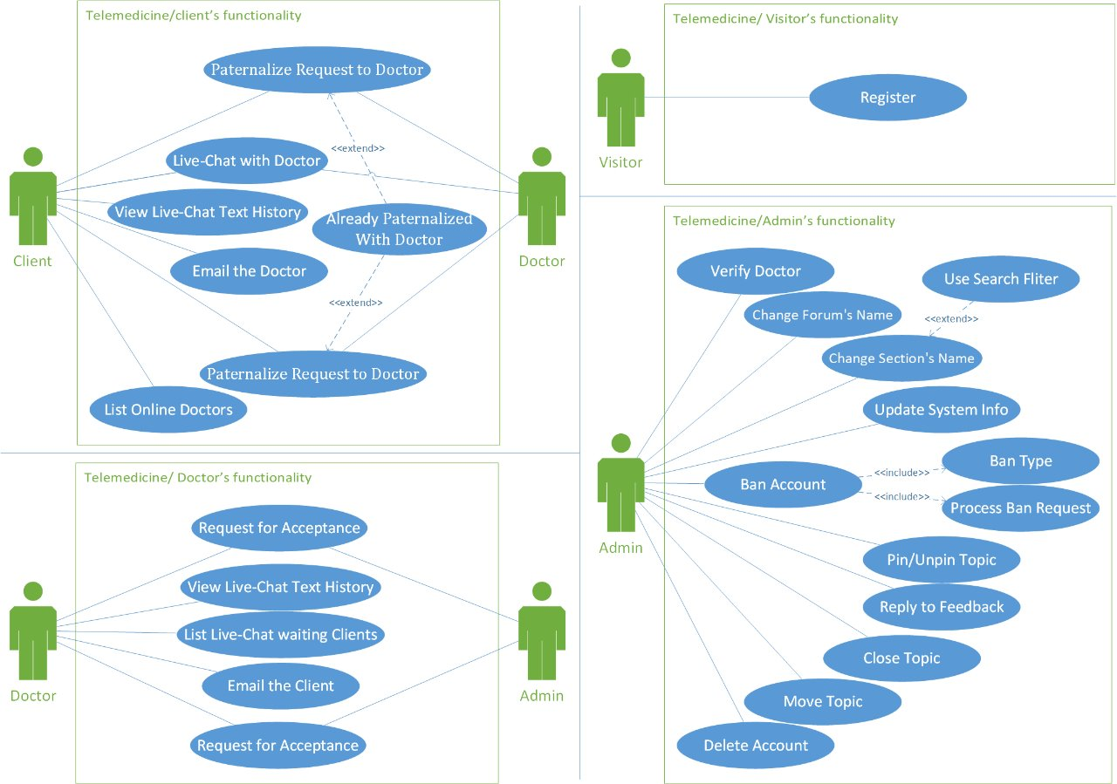

Figure1: Use case Diagram for each users

Figure2: Use case Diagram for each user

# 

# 

Figure2: Use case Diagram for all user

**PHASE 2 :-**

# 2.1/2.2 UML Class Diagram

# 

# 2.2.1 Associations

1. The System GUI grants access to the user GUI.
2. System GUI sends requests to the System Controller.
3. The System Controller modifies the System.
4. System GUI sends requests to the Form GUI.
5. Forum GUI sends requests to the Forum Controller.
6. The Forum GUI is managed by the Administrator.
7. The Forum Controller modifies the Forum.
8. The Forum Controller modifies the Section.
9. A Person updates the User GUI.
10. User GUI sends explore requests to the Topic Controller.
11. User GUI can do operations through the Topic Controller.
12. The User GUI is granted access by the System GUI.
13. The Topic Controller modifies the Topic.
14. Client GUI sends requests to the Client Controller.
15. The Client Controller modifies the Client.
16. Client Controller sends communication requests to the Communication Controller.
17. Doctor GUI sends requests to the Doctor Controller.
18. The Doctor Controller modifies the Doctor.
19. Doctor Controller sends communication requests to the Communication Controller.
20. The Administrator GUI can modify the Administrator.
21. Administrator manages the Forum GUI.
22. A Client is paternalized by Doctor.
23. A Doctor paternalizes a Client.
24. Communication Controller gets requests from the Client Controller.
25. Communication Controller gets requests from the Doctor Controller.
26. Communication Controller sends requests the Private Communication.

## **Composition**

1. The System has Forum.
2. The forum is part of the system
3. The section has topic.
4. The topic is part of section.
5. The forum has section.
6. The section is part of forum.
7. The topic has a reply.
8. The reply is part of topic.

## **Aggregation**

1. The live chat has a message.
2. The message is part of live chat.
3. The mail system has a message.
4. The message is part of the mail system.

# 2.2.2 Multiplicity

1. A System GUI is accessed by many User GUIs.
2. Many User GUI accesses 1 System
3. A System GUI sends requests to 1 System Controller.
4. A System Controller modifies 1 System.
5. A System GUI sends requests 1 Form GUI.
6. A Forum GUI sends requests 1 Forum Controller.
7. A Forum GUI is managed by many Administrators.
8. A Forum Controller modifies 1 Forum.
9. A Forum Controller modifies 1 Section.
10. A Person updates 1 User GUI.
11. Many User GUIs send explore requests to 1 Topic Controller.
12. A User GUI can do operations through to 1 Topic Controller.
13. Many User GUIs are granted access by 1 System GUI.
14. A Topic Controller modifies many Topic.
15. Many Client GUIs send requests to 1 Client Controller.
16. A Client Controller modifies many Client.
17. A Client Controller sends communication requests to 1 Communication Controller.
18. Many Doctor GUI sends requests to 1 Doctor Controller.
19. A Doctor Controller modifies 1 Doctor.
20. A Doctor Controller sends communication requests to 1 Communication Controller.
21. An Administrator GUI can modify 1 Administrator.
22. Many Administrators manage 1 Forum GUI.
23. A Client are paternalized by Many Doctors.
24. A Doctor paternalizes Many Client.
25. Communication Controller gets requests from 1 Client Controller.
26. Communication Controller gets requests from 1 Doctor Controller.
27. Communication Controller sends requests to many Private Communication.
28. A System has 1 Forum
29. A forum is part of 1 System
30. A System has many Registered Users
31. A Registered User is part of 1 System
32. A Mail System has many Messages
33. A Message is part of 1 Mail System
34. A Live Chat has many Messages
35. A Message is part of 1 Live Chat
36. A Forum has 23 Sections
37. A Section is part of 1 Forum
38. A Section has many Topics
39. A Topic is part of 1 Section
40. A Topic has many Replies
41. A Reply is part of 1 Topic

# Generalization

1. A Visitor is a Person
2. A Registered User is a Person
3. An Administrator is a Registered User
4. A Client is a Registered User
5. A Doctor is a Registered User
6. A Mail System is a Private Communication
7. A Live Chat is a Private Communication
8. Client GUI is a User GUI.
9. Doctor GUI is a User GUI.
10. Administrator GUI is a User GUI.
11. Visitor GUI is a User GUI.

**PHASE 3 :-**

# Sequence Diagram

# 3.1.1: Sequence Diagram for Search for Topic

# 

Figure4: Sequence diagram 1

3.1.2: Sequence Diagram for Start Live Chat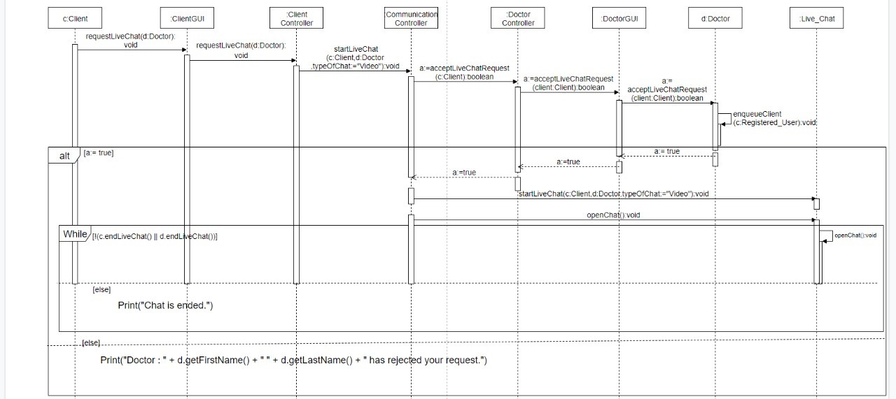

Figure5: Sequence diagram 2

# State Diagram

# 3.2.1: Delete Topic

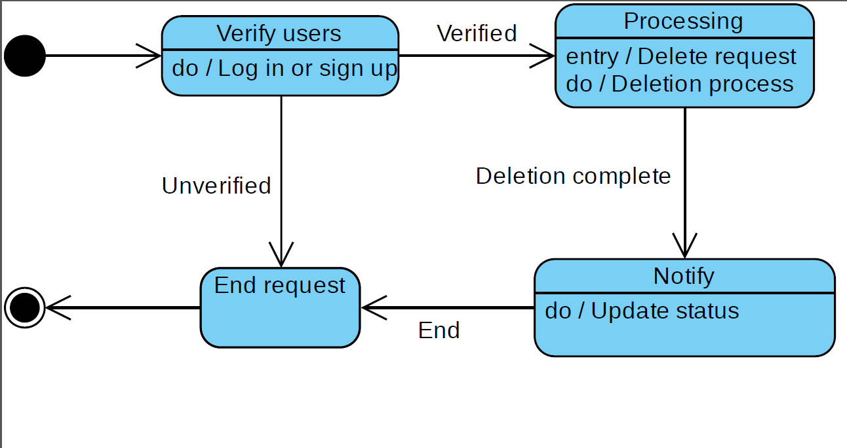

Figure6: State Diagram 1

# 3.2.2: Start Live Chat

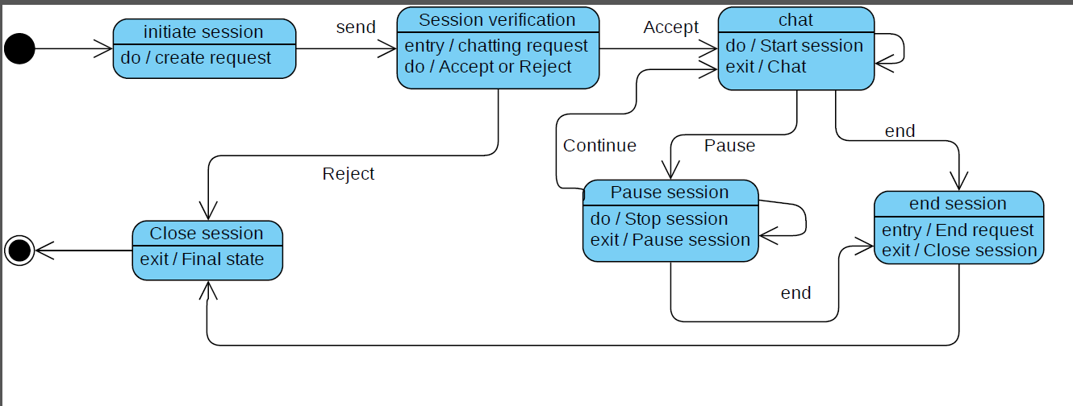

Figure7: State Diagram 2

# Activity Diagram

Figure8: Activity Diagram 1

# 3.3.2: Activity Diagram for a Doctor to be verified

Figure9: Activity Diagram 2

# 3.3.3: Activity Diagram for a Client requests to get paternalized from a Doctor

Figure10: Activity Diagram 3

# Architecture Diagram

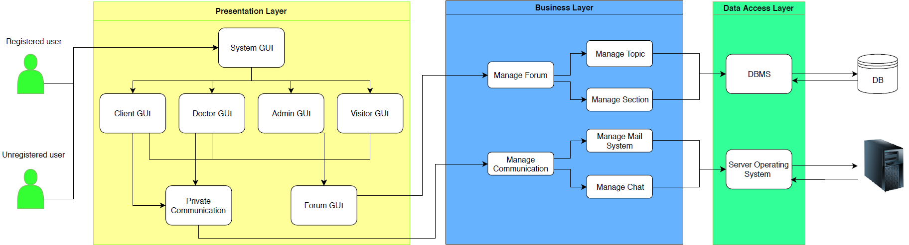

Figure11: Architecture Diagram 1

**PHASE 4:**

* 1. **Test Design scenarios:**
     1. **Crate Topic Test:**

|  |  |  |  |  |
| --- | --- | --- | --- | --- |
| Table 33: Decision Table Testing – Create Topic | | | | |
| Registered | F | T | F | T |
| Logged In | F | F | T | T |
| Expected Result | Error: must register or login to continue | Error: must register or login to continue | Error: wrong E-mail or password | Creating the topic |

* + 1. **Live Chat Test:**

|  |  |  |  |  |
| --- | --- | --- | --- | --- |
| Table 34: Decision Table Testing – Live chat | | | | |
| Request (Client) | F | T | F | T |
| Approval (Doctor) | F | F | T | T |
| Expected Result | - | Live chat request process canceled | - | Starting live chat session |

**BIBLIOGRAPHY :**

1- Almasri, M. (2010, August 2). *التطبيب عن بعد: ثورة في عالم الرعاية الصحية*. [Telemedicine: A revolution in the health care world].

Retrieved from http://www.albahethon.com/?page=show_det&id=991

2- Vicenzo, D. (2001, June 22). *What is e-Health (2): The death of telemedicine?*

Retrieved from https://www.ncbi.nlm.nih.gov/pmc/articles/PMC1761900/

3- https://www.moh.gov.bh (n.d.) Retrieved from

https://www.moh.gov.bh/HealthInstitution/SocialWorker_Objectives

4- Alsadi, N. (2016, January 31).[ *أهداف النظام الصحي*. ][Goals of the health system].

Retrieved from http://m-quality.net/?p=7704

5- Aljuaid, M. (2019, February 16). [*من المرضى يفضلون استخدام التطبيقات الرقمية للرعاية الصحية 54%*.] [54% of patients prefer using digital health care applications].

Retrieved from https://www.alwatan.com.sa/article/399191/54-من-المرضى-يفضلون-استخدام-التطبيقات-الرقمية-لل

**APPENDIX-A:**

**Update and meeting table**

|  |  |  |  |  |
| --- | --- | --- | --- | --- |
| Table 35: Update and meeting table | | | | |
| Date | **Phase** | **Description** | **Authors** | **Duration** |
| 20 - October | **1** | * **Collect the requirements** * **Use case diagram draft** | **All team members** | **5:00PM to 8:00PM (Online chat)** |
| 21 - October | * **Initial report and Requirements** | **All team members** | **4:00PM to 5:30PM**  **8:00PM to 10:00PM (Online chat)** |
| 29 - October | **2** | * **Review Phase 1** * **UML Class diagram draft** | **1742589**  **1742403**  **1742559** | **1:00PM to 2:00PM** |
| 31 - October | * **UML Class diagram review** | **1742589**  **1742403**  **1742559** | **1:00PM to 2:00PM** |
| 3 - November | * **UML Class diagram review** | **All team members** | **1:00PM to 2:00PM** |
| 4 - November | * **Requirements use cases and use case diagram are updated.** * **UML class diagram is created.** | **All team members** | **4:00PM to 6:00PM** |
| 12 - 30 November | **3** | * **Create sequence diagram** * **Update UML class diagram** | **1742589**  **1742403**  **1742559** | **-** |
| * **Activity Diagram** * **Architecture Diagram** * **State Diagram** | **1741096**  **1740216**  **1740166** |
| 4 - December | **Review Phase 3**  **Review UML Class Diagram** | **All team members** | **4:00PM to 6:00PM** |
| 5 – 10 December | **4** | **Review Phase 1, 2 and 3** | **1742589**  **1742403**  **1742559**  **1740166** | **-** |
| **Test the software (Phase 4)**  **Crate PowerPoint presentation** | **1741096**  **1740216** |

**APPENDIX-B:**

Interview questions:

Q1. Haw you can contact with your Doctor ?

A1. Via WhatsApp

Q2. Do you think it is good way to communicate with your Doctor ?

A2. Yes

Q3. If there is an app that can help you to communicate to many Doctor in any field Would you use it ?

A3. Of course

Q4. What are the problems that you face when you want to communicate with your Doctor?

A4. He is not always available and there are many other patients try to contact with him at the same time

Q5. If there is another available Doctor would you like to communicate with him?

A5. Yes